FLF Development Network - Plus Funds Application Form

Please return your completed form to hello@flfdevnet.com. The Plus Funds are a rolling call; applications can be made any time until August 2023. Please refer to our Plus Funds Guidance, or contact our Community Manager Bridget via hello@flfdevnet.com for further information.
IF YOU REQUIRE ANY CHANGES TO THIS FORM FOR ACCESSIBILITY, PLEASE CONTACT HELLO@FLFDEVNET.COM

Team Details

This information will be redacted prior to assessment by Plus Fund Review Group to ensure anonymity; Lead Applicant must be a member of the FLF Development Network (an FLF in Cohorts 1, 2 or 3 or a nominated early career researcher)
Applications from multiple FLFs and institutions working together are encouraged

Please provide an overview of team expertise, motivation, and ability to complete the project
Lead applicant
Name
Post
Department
Institution
Region | Scotland and NI / North and Midlands / London and SE / West and Wales
Email
Phone
Co-applicant (add sections as necessary)
Name
Post
Department
Institution
Region | Scotland and NI / North and Midlands / London and SE / West and Wales
Email
Phone
Overview of Team Expertise (suggested 200 words)
NOTE: As names and institutions will be redacted for anonymity, please ensure your overview gives sufficient detail for the Review Group to assess the breadth and expertise of your team.
Team Details - To be completed by Plus Fund Review Group
Score (out of 5): |  | Weighting: 10% | Total (S x W): /50
Review Group feedback

Project Details
Please provide a brief description of your proposed activity. This should include the format of the activity (eg workshop, public engagement event),and the research and innovation aims of your activity (in line with our Signature Themes and Spheres of Influence - Annex 1)

If this is a resubmission of an earlier request for funding, please include your previous Plus Funds reference number
Project Title
Project Details (suggested 250 words)
Project Details - To be completed by Plus Fund Review Group
Is the proposed activity in scope for Plus Funds funding? YES/NO
If yes, continue to assess the application below. If no, explain here how it is out of scope.
Score (out of 5): |  | Weighting: 15% | Total (S x W): /75
Review Group feedback

Project Implementation
Please identify a clear timetable and plan for implementation of your activity, as well as measurable deliverables.
Objectives and Aims of Activities (suggested 500 words):
Project Implementation - To be completed by Plus Fund Review Group
Score (out of 5): |  | Weighting: 20% | Total (S x W): /100
Review Group feedback

Value for Money

Please provide a detailed breakdown of requested funding using the budget table template in Annex 2. Please also submit evidencing of proposed costs (eg quotes or invoices).

We strongly suggest that a 10% contingency fund be included in the proposed budget.
Proposed activities will be assessed for evidence of sensible and justifiable use of funds.
Total Requested Funding (up to maximum of £25,000)
Have you attached a completed budget table and provided evidence of costings?
Please identify other funding sources that may support the project’s further development and sustainability (if applicable)
Value for Money- To be completed by Plus Fund Review Group
Score (out of 5): |  | Weighting: 15% | Total (S x W): /75
Review Group feedback

Risk Assessment
Identify main risks facing the activity/ project, and provide considered strategies for management, mitigation and impact minimisation
Main risk factors and mitigation strategies (suggested 300 words)
Risk Assessment - To be completed by Plus Fund Review Group
Score (out of 5): |  | Weighting: 10% | Total (S x W): /50
Review Group feedback

Equality, Diversity and Inclusion
Please provide information of how unconscious bias and equality, diversity and inclusion (EDI) will be evidenced in the design, provision and outcomes of the activity.
Consideration of EDI and unconscious bias in design and provision of the activity (suggested 200 words)
Consideration of EDI and unconscious bias in proposed outcomes of the activity (suggested 200 words)
Equality, Diversity and Inclusion - To be completed by Plus Fund Review Group
Score (out of 5): |  | Weighting: 15% | Total (SxW): /75
EDI feedback

Enhancing FLF Support
Describe how the proposed activity will enhance / build upon existing resources within the FLF Development Network (refer to Annex 1 below)
Enhancing FLF Support (suggested 200 words)
Enhancing FLF Support - To be completed by Plus Fund Review Group
Score (out of 5): |  | Weighting: 15% | Total (S x W): /75
Review Group feedback

Data Protection
The information provided in this application form (and additional information such as budget tables) will be treated as confidential and used for the purposes of assessing the application and provision of reporting data to UKRI.
We consent to the information provided on this application form being processed as required to assess the application and administer the Plus Funds. |  | ☐
We consent to be contacted by the FLF Development Network in relation to this application. |  | ☐
We consent to details of the application and proposed Plus Funds activity being shared with UKRI for the Network's reporting commitments. |  | ☐
Signature
I confirm that the information given in this application is accurate to the best of our knowledge, and that we have read and will comply with the guidance notes for the Plus Funds activities.
Signature of Lead Applicant | Date

Annex 1 – The Network’s Signature Themes and Spheres of Influence

Our position on leadership is focused on the concept of influence. For many new leaders, who have likely achieved their position based on a career of personal successes, this can be the crux of the leadership challenge. How do they pass on their knowledge and skills? How do they get teams to think for themselves whilst working towards the same goal? How do they influence others to buy into their ideas and ambitions? There are no ‘one size fits all’ answers. Thus, our model prompts deep reflection about when, why, and how to engage across multiple spheres of influence:

A. Enterprise and self-leadership – the personal attributes, mindsets, and ethics which shape how we see the world, the communities within it, and the possibilities for change.
B. Leading teams and collaborations – the interpersonal and intercultural dynamics which affect how we build and lead diverse, effective, and innovative research teams and collaborations.
C. Transforming research cultures – the collective work to rethink established modes of working, identify practical intervention points, and build coalitions towards positive, inclusive research cultures.
D. Contributing to UK society – the vital importance of making a meaningful impact on UK society through commercialisation, knowledge exchange, public and policy engagement, and community partnerships.
E. Global citizenship – the equal, mutually beneficial, transnational, and multi-sectorial collaborations needed to tackle grand or global challenges.

Our signature themes are: [i] navigating uncertainty; [ii] collaborating inclusively; and [iii] transforming thinking. These themes span across the spheres of influence listed above.
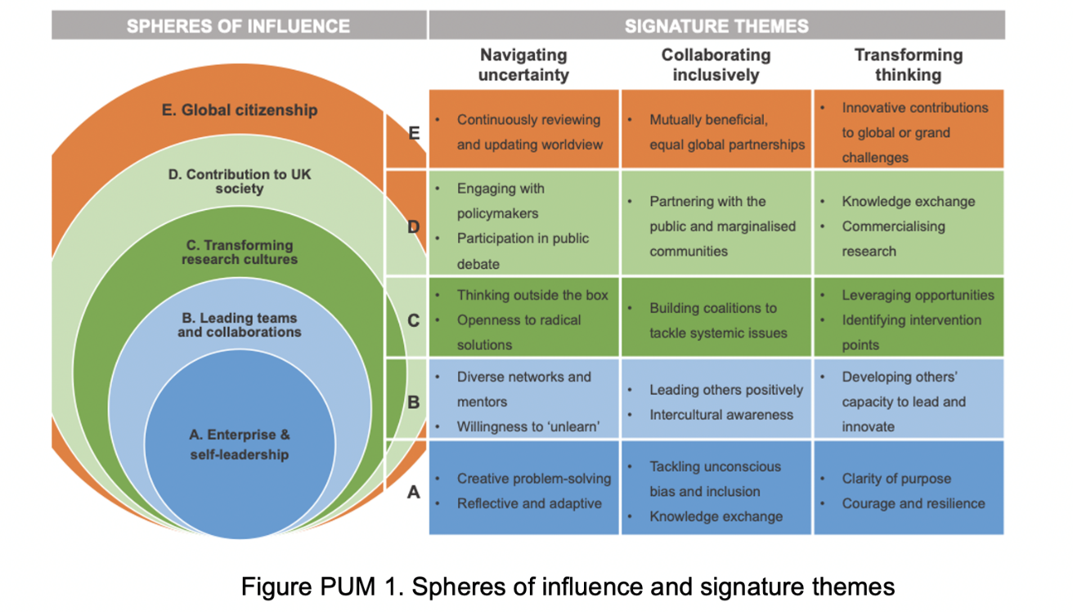

If you are unable to access or read the information provided in the organigraph above, please contact hello@flfdevnet.com for an accessible version of the embedded information.

